
BAKERSFIELD COLLEGE

Electronics

Raspberry Pi Pico - Project 04: Traffic Light

1. Introduction:
Traffic lights are closely related to people's daily lives, which generally show red, yellow, and green. Everyone should obey the traffic rules, which can avoid many traffic accidents. In this project, we will use Raspberry Pi Pico and some LEDs (red, green and yellow) to simulate the traffic lights.

The red LED lights up, followed by the amber LED. Both turn off as the green LED lights up. Green turns off, and amber lights up. Amber turns off, and the cycle begins again with the red LED.

2. Components Required:
Raspberry Pi Pico: The microcontroller that controls the LEDs.
One Red, One Yellow, and One Green LEDs to represent the traffic light.
Three 220Ω Resistors, used to limit the current flowing through the LEDs.
Breadboard: For connecting the components and making the project easier to build and modify.

3. Circuit Diagram and Wiring Diagram:
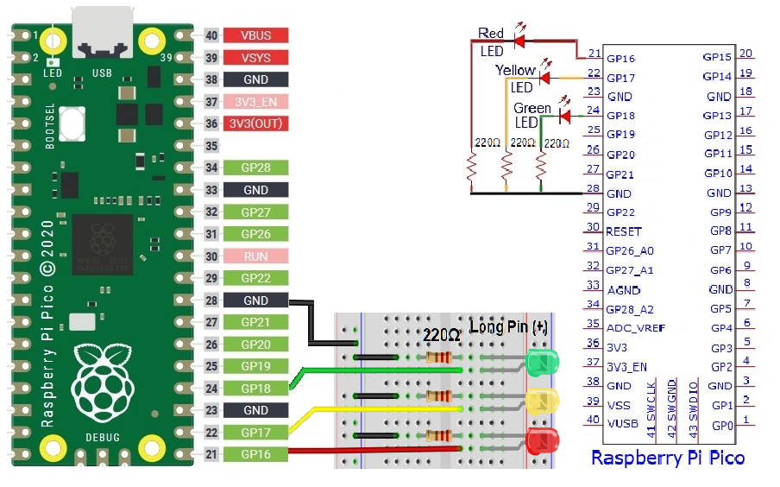


4. Test Code:
Open “Thonny , click “This computer”→“home”→“pi”→“Python_Code”→".

And double-click“#04 - LED Traffic Lights #1.py”.

#04 - Traffic Lights #1
from machine import Pin
import time

led_red = machine.Pin(16, machine.Pin.OUT) # Create red led object output on Pin 16.
led_yellow = machine.Pin(17, machine.Pin.OUT)# Create yellow led object output on Pin 17.
led_green = machine.Pin(18, machine.Pin.OUT) # Create green led object output on Pin 18.

while True:
led_red.value(1) # Set red led turn on
time.sleep(5) # Sleep 5s
led_red.value(0) # Set red led turn off
led_yellow.value(1)
time.sleep(0.5)
led_yellow.value(0)
time.sleep(0.5)
led_yellow.value(1)
time.sleep(0.5)
led_yellow.value(0)
time.sleep(0.5)
led_yellow.value(1)
time.sleep(0.5)
led_yellow.value(0)
time.sleep(0.5)
led_green.value(1)
time.sleep(5)
led_green.value(0)


5. Test Result:
Connect the pico board to the Raspberry Pi. Click to check the Shell
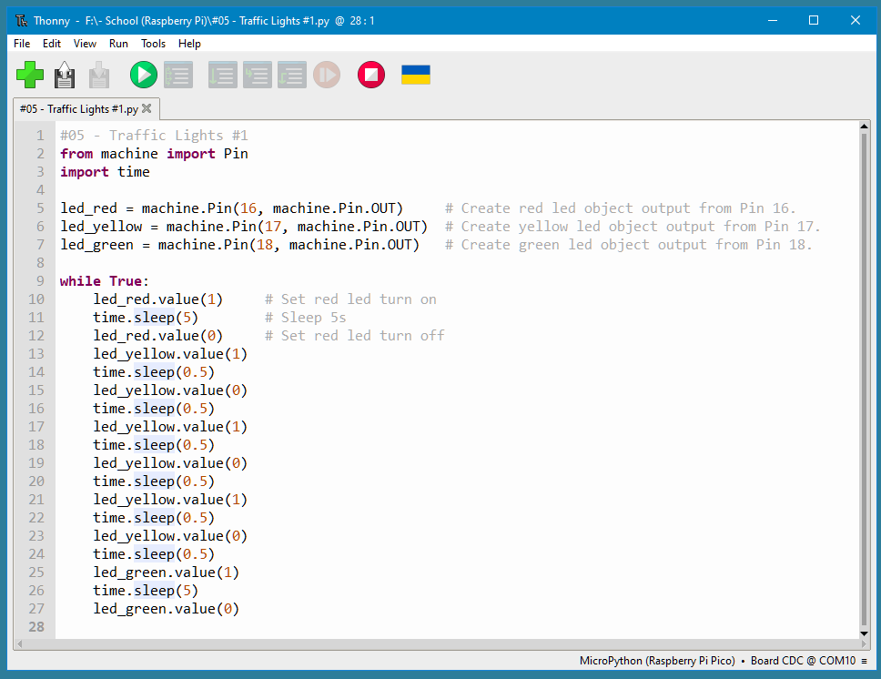
Click , the code starts executing, what we will see are below:

- First, the green light will be on for 5 sec. and then off;

- Next, the yellow light blinks three times and then goes off.

- Then, the red light goes on for five 5 sec. and then goes off.

- Repeat steps 1 to 3 above.

Press “Ctrl+C” or click to exit the program.

6. Wiring the Pedestrian Crossing:
Traffic light with pedestrian crossing simulator example for Pico. Turns on red, amber and green LEDs in traffic light-like sequence. When button is pressed, upon light sequence completion, the red LED turns on and the buzzer beeps to indicate pedestrian crossing is active.

This example requires your current hardware setup, plus a button switch, a piezo buzzer, and a few more male-to-male jumper wires.

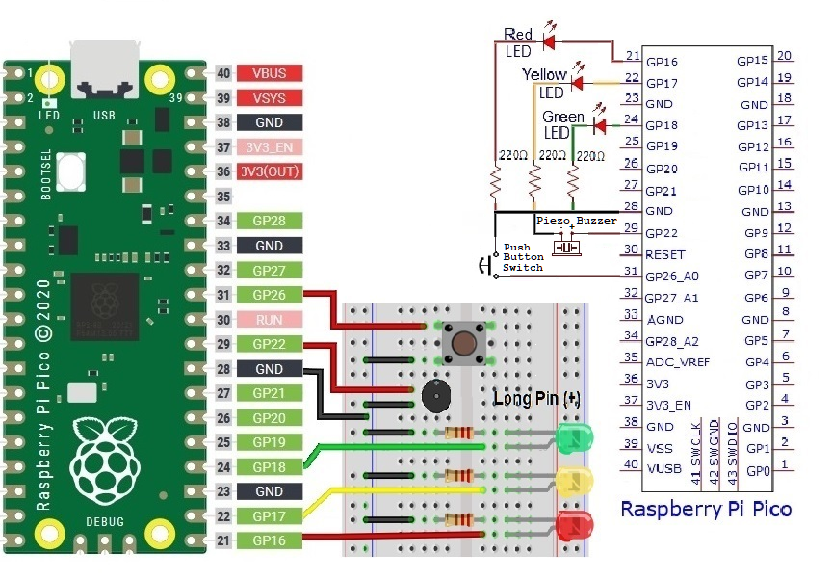
Connect the button switch and piezo to your current setup as shown below. The button is shown with jumper wires connected to two legs on the same side. Each pair of legs is shaped a bit like a staple. You should be able to identify the separate pairs and ensure you're connected to the opposite legs, even though you have the wires on the same side. The direction of the piezo doesn't matter.

7. Test Code:
Update your code to the following and save. Open “Thonny , click “This computer”→“home”→“pi”→“Python_Code”→".
And double-click“#04 - LED Traffic Lights #2.py”.

#04 - LED Traffic Lights with Pedestrian Crossing #1
import machine
import utime
import _thread

led_red = machine.Pin(16, machine.Pin.OUT) # Create red led object output from Pin 16.
led_amber = machine.Pin(17, machine.Pin.OUT) # Create yellow led object output from Pin
led_green = machine.Pin(18, machine.Pin.OUT) # Create green led object output from Pin 18.
button = machine.Pin(26, machine.Pin.IN, machine.Pin.PULL_DOWN) # Create button input from Pin 26.
buzzer = machine.Pin(22, machine.Pin.OUT) # Create buzzer object output from Pin 22.

global button_pressed
button_pressed = False # Button status as open.

def button_reader_thread():
global button_pressed # Button status as closed.
while True:
if button.value() == 1:
button_pressed = True

_thread.start_new_thread(button_reader_thread, ())

while True: # Checking button status open or closed and LED loop.
if button_pressed == True:
led_red.value(1)
for i in range(10):
buzzer.value(1)
utime.sleep(0.2)
buzzer.value(0)
utime.sleep(0.2)
global button_pressed
button_pressed = False

#Red -LED on value time.
led_red.value(1)
utime.sleep(5)
led_red.value(0)
#Yellow -LED on value time.
led_amber.value(1)
utime.sleep(3)
led_amber.value(0)
#Green -LED on value time.
led_green.value(1)
utime.sleep(5)
led_green.value(0)

The light sequence is the same as before. This time, however, you can press the button, and when the light sequence completes, the red LED will stay on and the piezo will play a series of beeps. Then the light sequence will begin again.

You can repeat this as often as you like.

Now, a detailed look at the code. First, you import the necessary modules. This example uses the same three as the previous example, but also requires a new module: pwmio.

